# 1. Project Overview:

This is a project where a patient can create appointment, prescription, and add, remove or update the prescribed medicines.

# 2. Project Setup:

In MySql database create a database named **“EmployeeManagementApp”**.

And do the following changed in the **“Application.properties”** file

spring.datasource.url=jdbc:mysql://localhost:3306/ appointBooking09_02_2025

spring.datasource.username=root

spring.datasource.password=enter your database password

After updating the application.properties file in the project, the script will look like the below given image.

spring.application.name=Appointment-Booking  
spring.datasource.url=jdbc:mysql://localhost:3306/appointBooking09_02_2025  
spring.datasource.username=root  
spring.datasource.password=password   
spring.jpa.properties.hibernate.dialect=org.hibernate.dialect.MySQLDialect  
spring.jpa.hibernate.ddl-auto=update  
spring.jpa.show-sql=true

# 3. Screenshots:

## 3.1 Login Screen

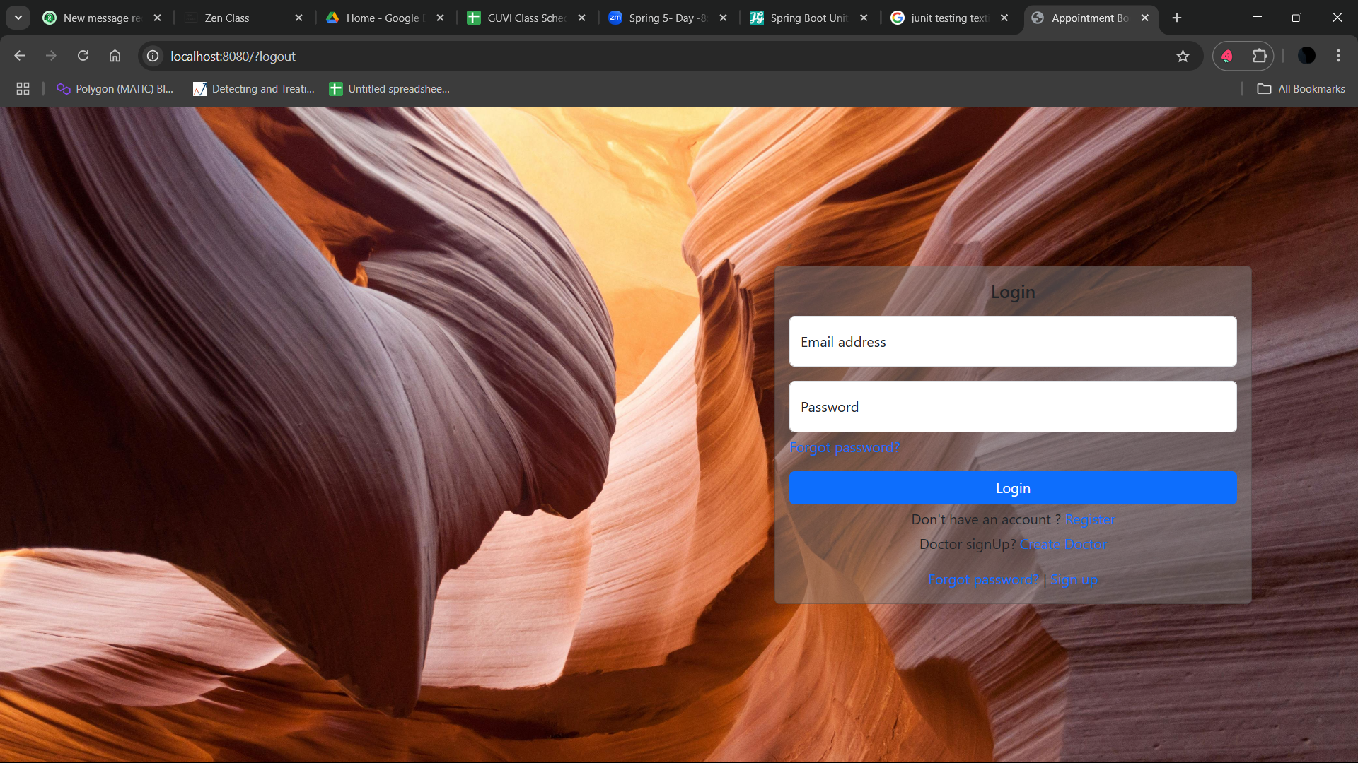

## 3.2 Patient Registration Screen

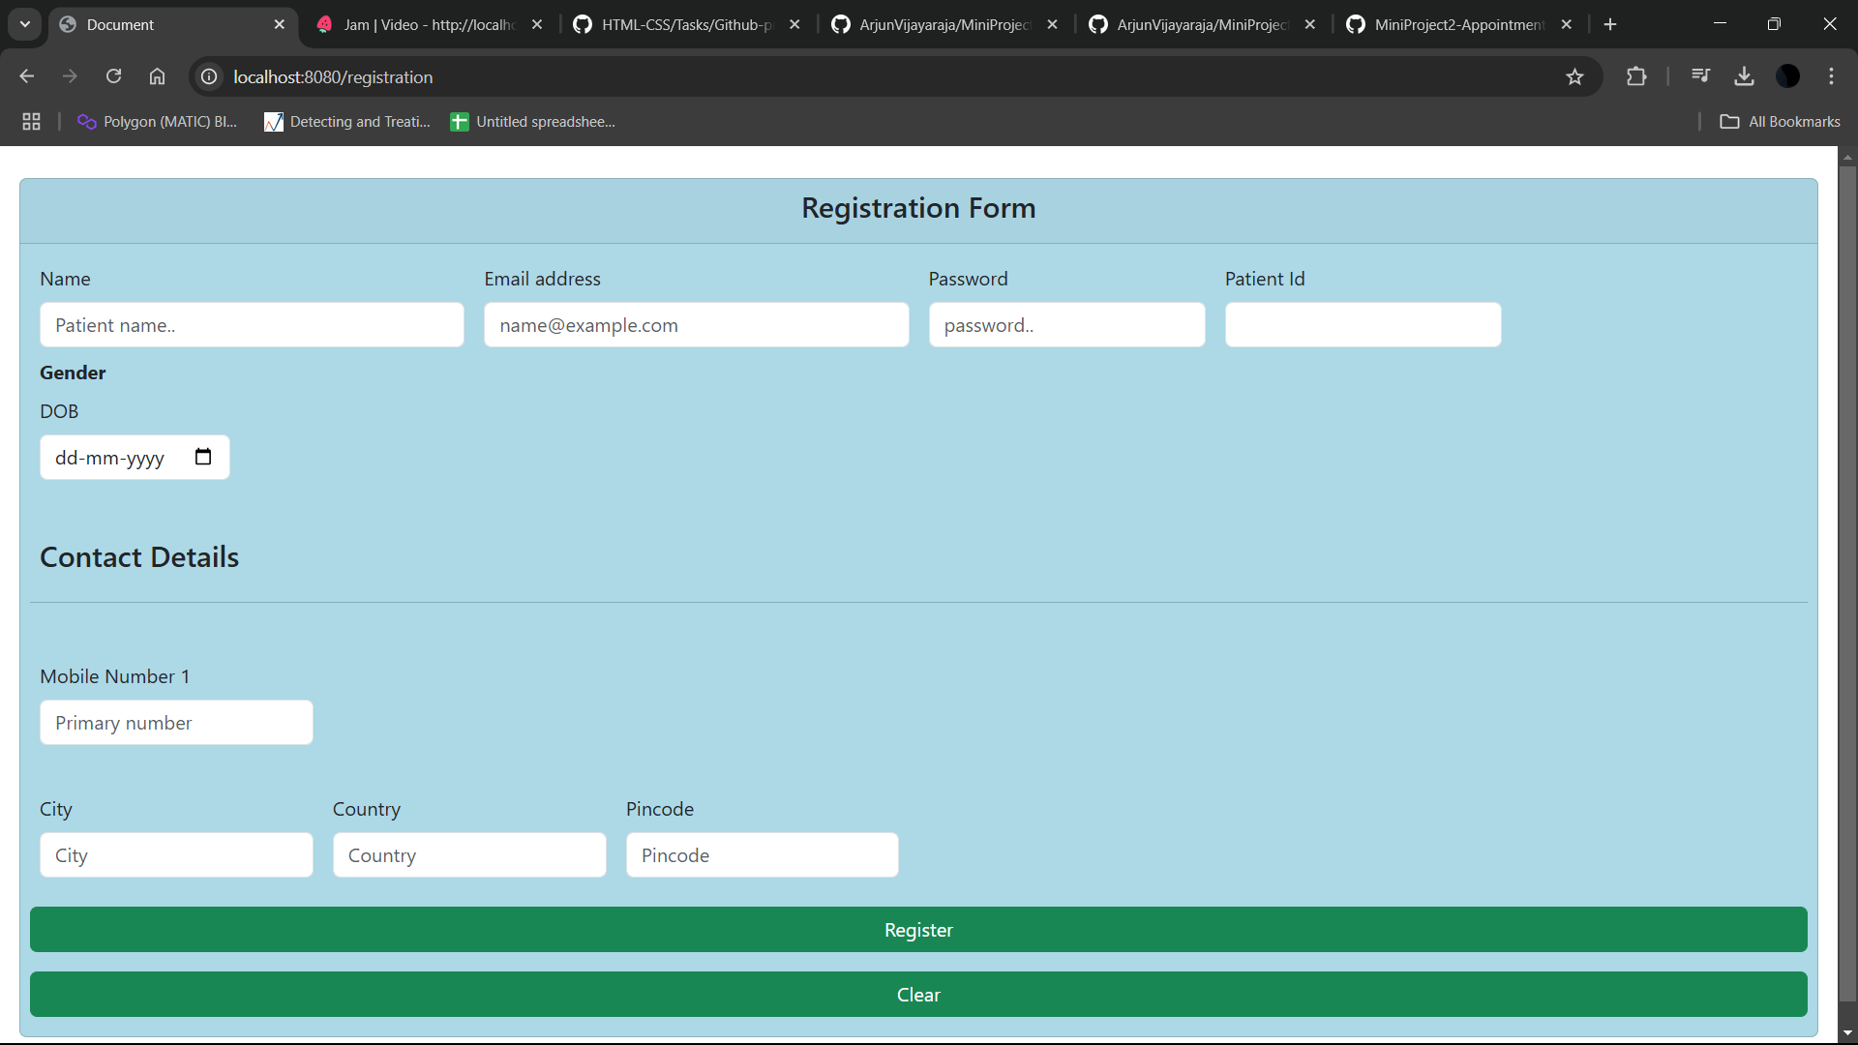

## 3.3 Patient Registration page with validations

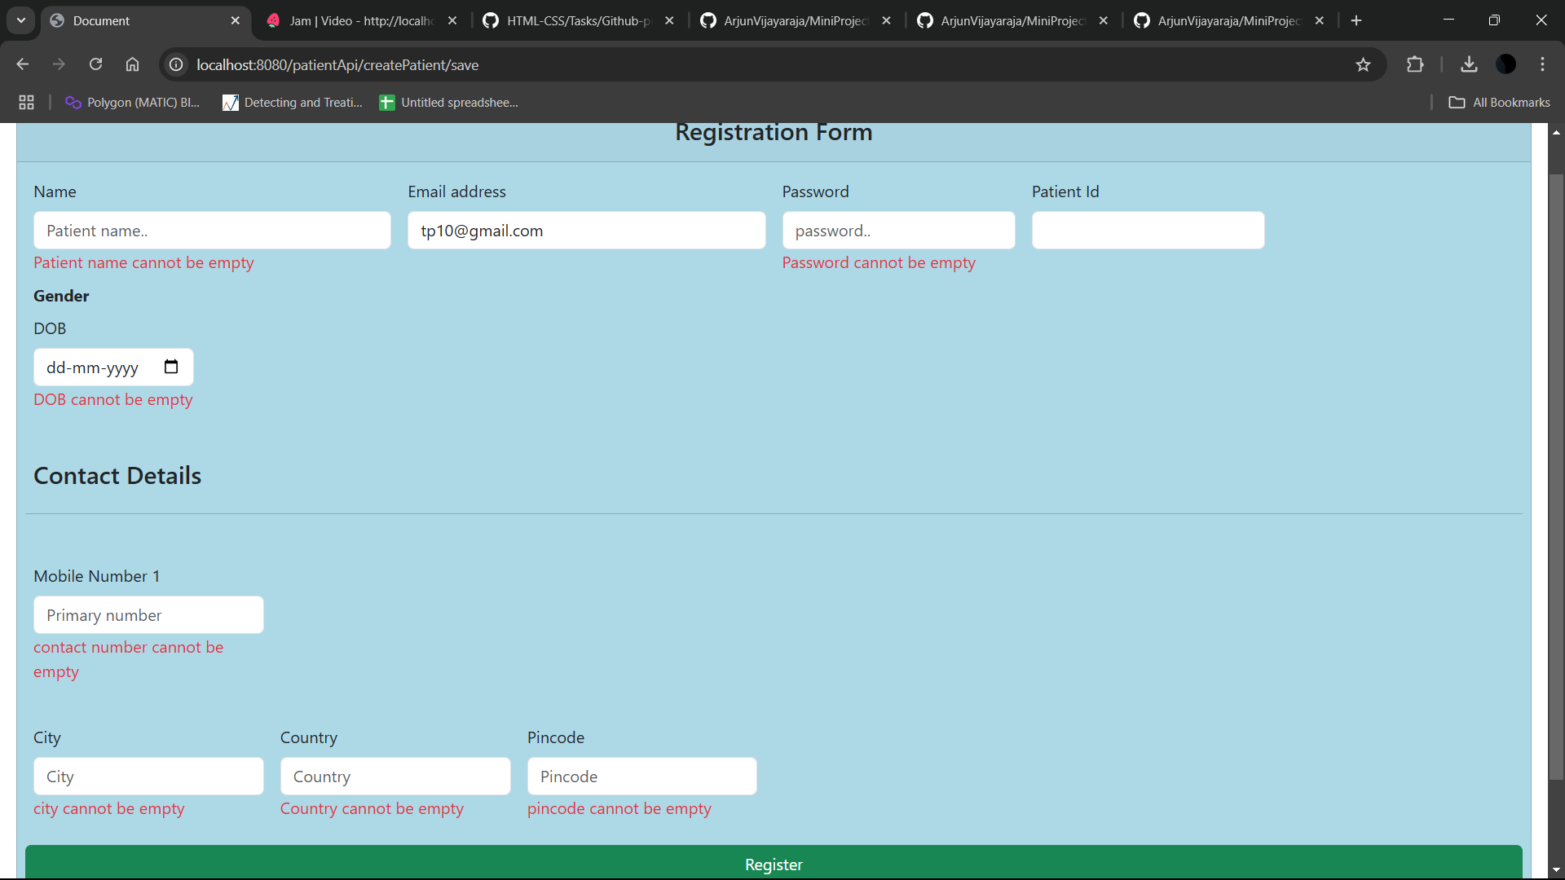

## 3.4 Appointment Screen

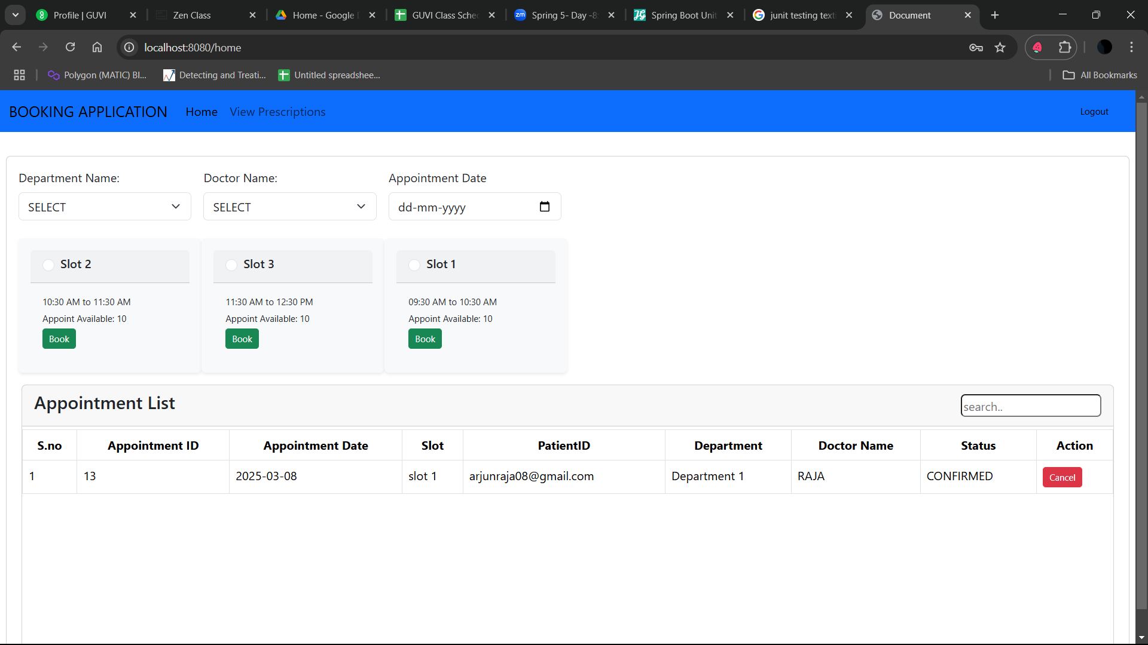

## 3.5 Appointment Screen with validation

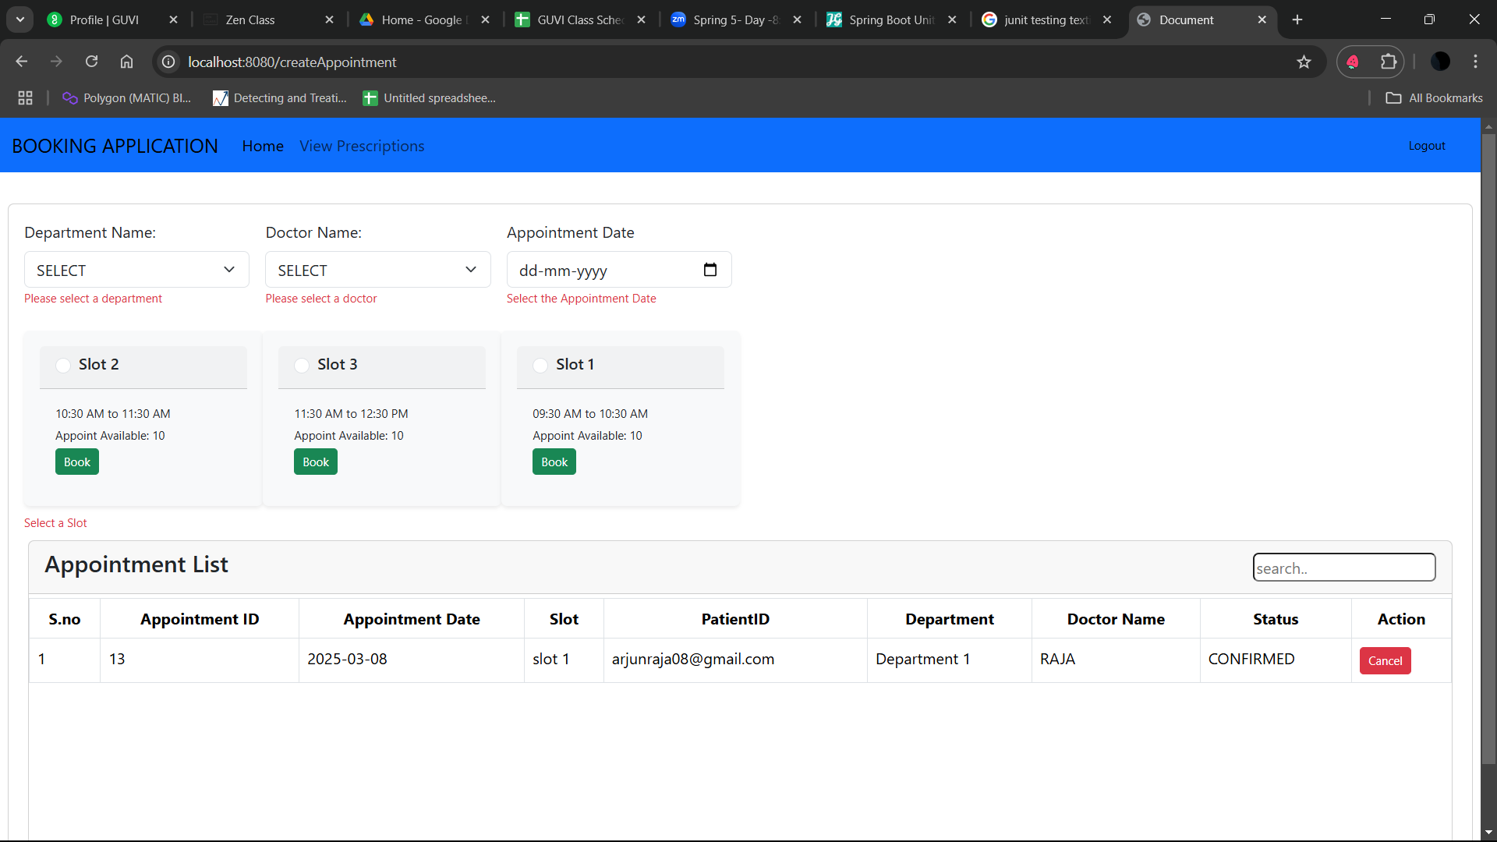

## 3.6 Patient – Prescription View Screen

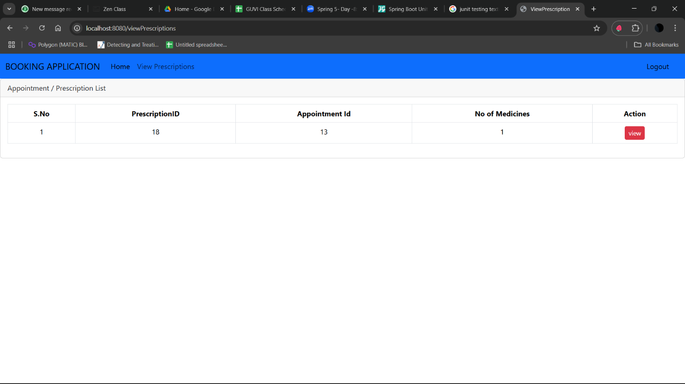

## 3.7 Prescribed Medicines – View Screen

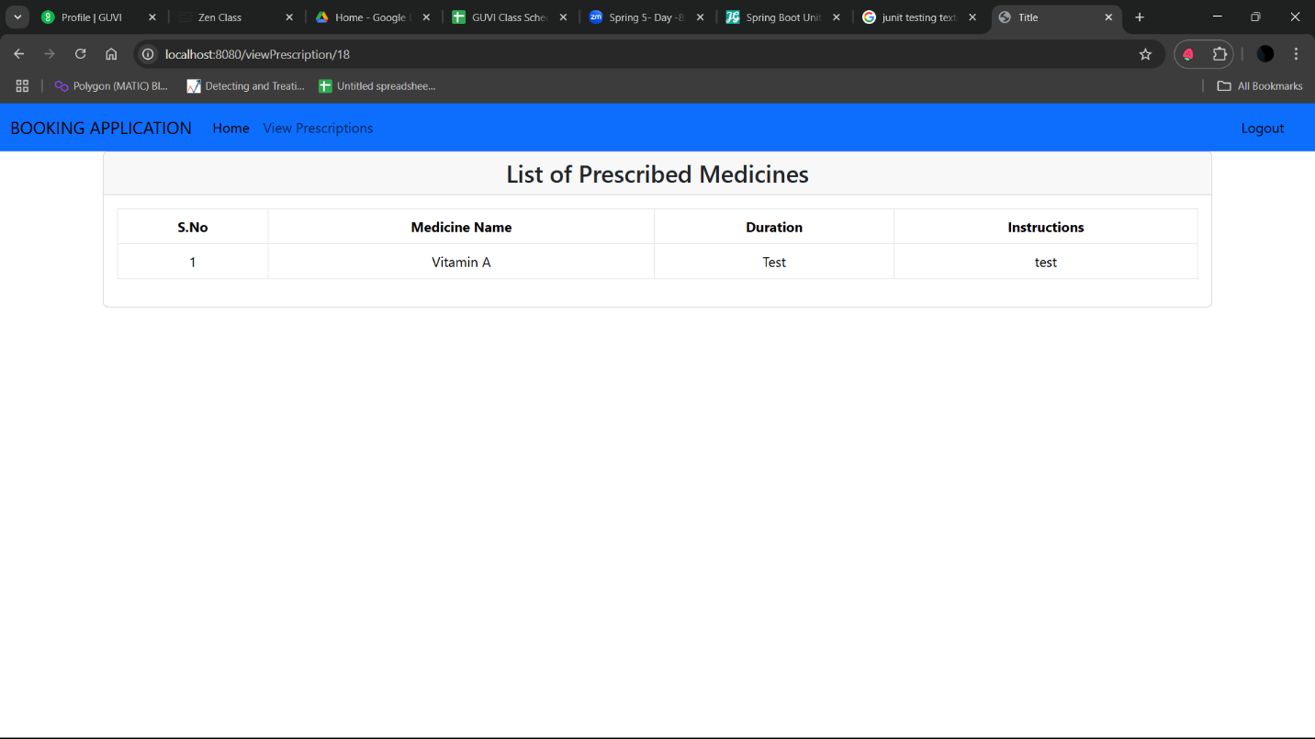

## 4. Doctor Registration Screen

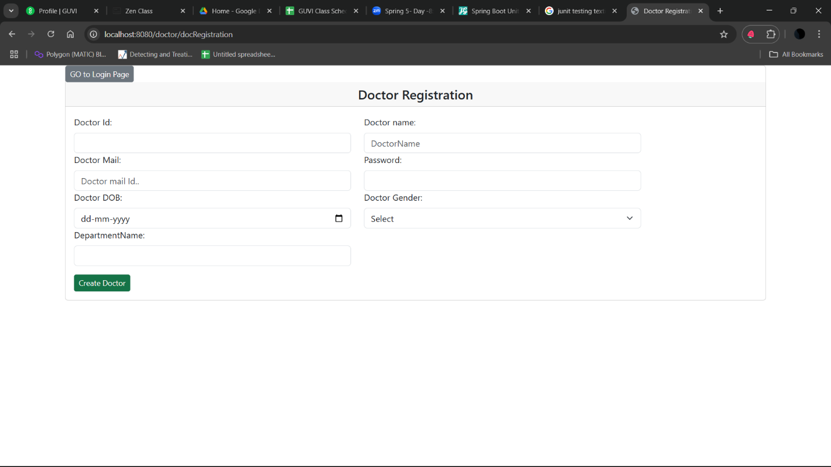

## 4.1 Doctor – Patient Appointments View Screen

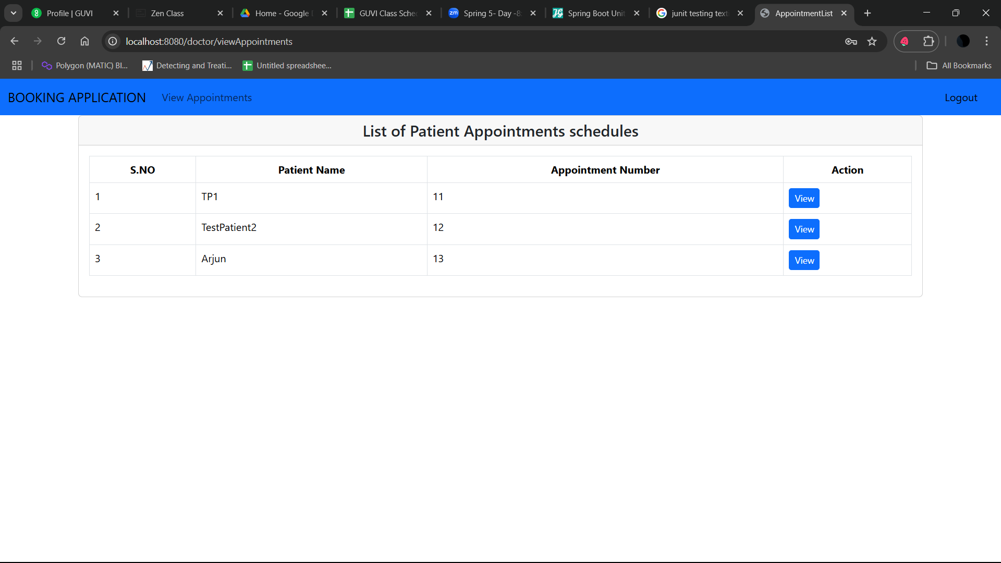

## 4.2 Doctor Prescription Creation screen

